Scheda 1

Knowledge Spillovers and the Geography of Innovation

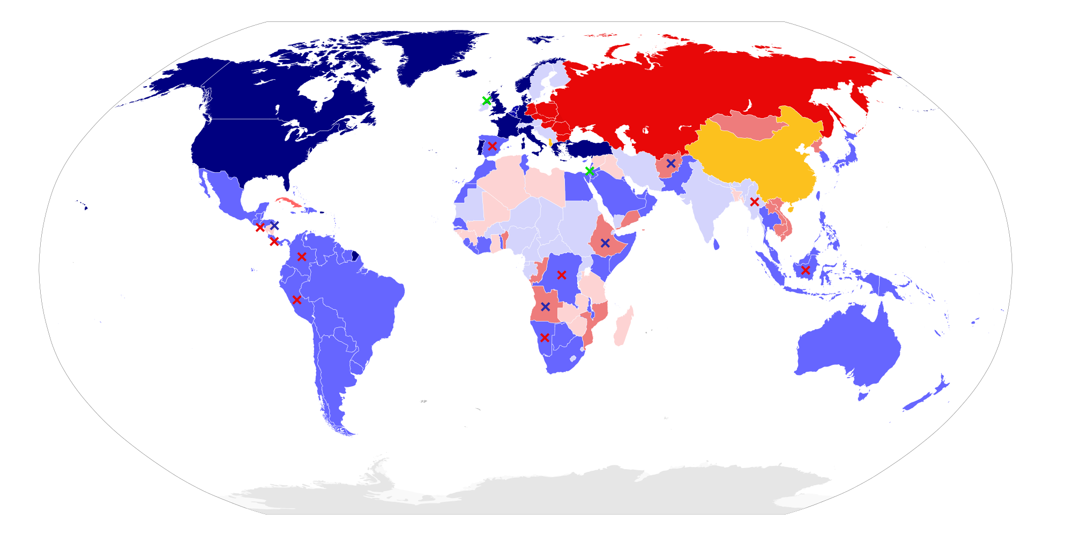

Introduction:
Literature: Handbook of Regional and Urban Economics, Chapter 61, Volume 4, 2004 by David B. Audretsch and Maryann P. Feldman

STRUCTURE
Possibile scaletta
https://www.canva.com/design/DAGl7M3eKHU/5m5lBz5QxPTvicWQ7K08_Q/edit

- Introduction : Innovation (Simona)
Definitions : radical innovation, disruptive innovation, grapes of innovation
Cycles of innovation (destruction créatrice), intro on the role of entrepreneurs in innovation
Teasing on the rest of the subject
Schumpeter (chap 2E)
Path dependency
Simple definition of knowledge (tacit, codified…), codification of knowledge
Dilemme incitation vs diffusion

- “Why does geography matter for innovation?” (Giorgia)
  - definition of knowledge spillovers
  - definition of knowledge function
  - show a map representing areas that produce innovation and tease on why this could be happening
  - definition of innovation cluster

3. “How do Spillovers work?” (Enrico)
  - Formal models
    - Marshall-Arrow-Romer Model (Specialization)
      - Knowledge spreads more efficiently within specialized industries.
      - Example: Detroit’s auto industry.
What happens when clusters fail?
    - Jacobs' Model (Diversity)
      - Cities benefit from diverse industries cross-pollinating ideas.
      - Example: New York’s financial and tech hybrid ecosystem.
  - Further reasons
    - communication → globalization of information
    - labor mobility *generic
    - universities and research labs *generic
    - entrepreneurship (?)
    - introduction to importance of institutions *generic
4. Role of institution - public authorities (Sofia)
- public investments - incentives
*how did South Korea or China build an innovation hub?
*chart showing how much each nation invests in innovation and size of their industries
- university:
  - policies encouraging researchers of university
  - university-industry collaboration → connection to universities and research labs:
- Should governments fund university research more? What happens when clusters fail?
→ ex:
- Startups
- Real companies doing this: google, ibm, pfizer, tesla, intel
- fuga di cervelli (workers retention) and attraction of skilled labor → LABOR MOBILITY
  - Golden visas, startup grants, tax breaks for skilled workers (e.g., UAE’s remote work visa).
  - Visa & immigration policies: Talent migration restrictions slow down global knowledge diffusion.
→ more than one cittadinanza can be a barrier → China, Russia and north korea?
5. Limits to spillovers (Teo)

- Geopolitics
*immagration policies?
- Absorptive capacity

  - Geopolitics
    - trade wars and sanctions
    - restrictions on knowledge exchange due to geopolitical tension (US-China tech war)
  - Knowledge gap
  - Intellectual property and Knowledge hoarding:
Companies & institutions might avoid sharing knowledge to maintain competitive advantage.
  - Technological & Infrastructure Barriers

Wrap-up (Giorgia)
a. conclusion

memes pookie

🌟 1. Introduction (10-15 min) → "Why Does Geography Matter for Innovation?"

✅ Engaging Question: Ask: “Why do some places (Silicon Valley, Boston, etc.) keep producing innovations, while others struggle?”
✅ Meme Moment → Show a funny "corporate cringe" meme about innovation hubs.
✅ Quick Overview: Define knowledge spillovers, urbanization economies, and localization economies (but keep it light—just teasing what’s coming).

🧠 2. The Science of Innovation Clusters (15-20 min) → How Do Spillovers Work?

✅ Graphs & Data from the Paper 📊 → Show a map of innovation clusters and explain why some cities dominate.
✅ How Do Spillovers Happen?

Universities & Research Labs

Talent & Labor Mobility

Informal Knowledge Sharing (social networks, coffee shops, tech meetups)
✅ Example: How Tech + Fashion Cross-Pollinate in NYC (Urbanization Economy)
✅ Example: Why Pharma Firms Cluster Around Boston (Localization Economy)

🏛 3. BIG COMPANIES PARTNERING WITH UNIVERSITIES FOR R&D (20-25 min) → Why Do They Do It? (Even when they have internal R&D labs!)

✅ Why Do Corporations Work with Universities?

Access to cutting-edge research before competitors

Cheaper long-term investment (outsourcing deep research instead of in-house)

Pipeline for recruiting top PhD talent

Public funding benefits (governments often subsidize university R&D)

✅ 💡 CASE STUDIES → REAL COMPANIES DOING THIS:

Google & Stanford → Google was literally born out of Stanford’s research! Google still funds AI & quantum computing research there.

IBM & MIT → IBM partnered with MIT for AI research ($240M investment) to advance machine learning.

Pfizer & Harvard Medical School → Pharma giant Pfizer collaborates with Harvard to develop new drugs and conduct clinical research.

Tesla & University of Nevada → Partnered for battery R&D because Nevada has a growing energy research hub.

Intel & UC Berkeley → Funds semiconductor research to get ahead of competitors.

✅ Meme Idea for This Section:
🧠 Corporate R&D Teams: “We have a $500M research budget.”
🔬 Also Corporate R&D Teams: “Hey PhD students, can you do this for us for free?” (insert meme about unpaid research interns 😂)

📍 4. Policy & Economic Impact (15 min) → How Can Governments Build Innovation Clusters?

✅ How Did South Korea Build an Innovation Hub? (Seoul Tech Boom)
✅ What Happens When Clusters Fail? (Detroit’s Decline)
✅ Should Governments Fund University Research More? → Debate-style discussion!

💼 5. Entrepreneurship & Startups (15 min) → Why Clusters Help New Companies Succeed

✅ Why Do Startups Thrive in Clusters?
✅ Case Study: Why So Many Billion-Dollar Startups Come from Stanford & MIT
✅ Venture Capital & Its Role in Clusters (Graph: Where VC Money Goes)
✅ Are Remote Startups Killing Innovation Clusters? → Mini Debate

🎤 6. Wrap-Up & Q&A (10 min)

✅ Recap: Why Location Matters for Innovation
✅ Ask: "What city do you think will be the next big innovation hub?"
✅ Close with funny meme or provocative final thought (e.g., "What if AI replaces R&D altogether?")

🔥 EXTRA SPICE TO KEEP IT FUN 🔥

💡 Turn One Section into an Audience Game!

Show two cities (e.g., Boston vs. Miami) → Ask the audience to predict which has more startups, VC funding, or innovation clusters.

Then reveal the answer with a cool graph or map!

📊 Graph Ideas for Your Presentation:

Map of Global Innovation Hubs 🌎

VC Funding by Region 💰

University-Industry Research Funding Over Time 📈

😂 Memes for Engagement:

“Ah yes, let’s fund university research and then hire all their grads” (meme of corporate execs rubbing hands greedily)

“Silicon Valley in 2000: 'We build computers.' Silicon Valley in 2024: 'We make subscription apps for dog food deliveries.'”

🚀 STRUCTURE FOR A 90-MINUTE PRESENTATION 🚀

1. Introduction (10-15 min) → "Why Does Geography Matter for Innovation?"
Talking Points:
- The Importance of Location in Innovation:
  - Discuss how certain regions become innovation hubs due to factors like proximity to universities, availability of venture capital, and a culture that fosters entrepreneurship.
- Knowledge Spillovers:
  - Explain how ideas and innovations spread more rapidly in geographically concentrated areas, leading to accelerated technological advancements.
Sources:
- Developing Successful Strategic Partnerships With Universities

2. The Science of Innovation Clusters (15-20 min) → How Do Spillovers Work?
Talking Points:
- Mechanisms of Spillovers:
  - Universities & Research Labs: Highlight their role in conducting foundational research that industries can later apply.​
  - Talent & Labor Mobility: Discuss how professionals moving between organizations facilitate knowledge transfer.​
  - Informal Knowledge Sharing: Emphasize the significance of networking events, conferences, and informal gatherings in spreading ideas.​
- Urbanization vs. Localization Economies:
  - Urbanization: Diverse industries in a city leading to cross-industry innovations.​
  - Localization: Specialized regions where specific industries dominate, fostering deep expertise.​
Sources:
- Developing Successful Strategic Partnerships With Universities

3. Big Companies Partnering with Universities for R&D (20-25 min) → Why Do They Do It?
Talking Points:
- Motivations for Collaboration:
  - Access to Cutting-Edge Research: Universities often lead in pioneering studies, providing companies with early insights.​
  - Cost-Effective Research: Collaborating can be more economical than maintaining expansive in-house R&D departments.​
  - Talent Pipeline: Partnerships allow companies to identify and recruit top emerging talent.​
  - Shared Resources: Utilizing university facilities and equipment can reduce costs.​
- Case Studies:
  - Novartis and Harvard University:
    - Collaborated on biomedical research, leading to significant advancements in drug development.
    - Source: Top 5 Corporate–Academic Collaborations in Biomedical Sciences
  - Procter & Gamble and University of Cincinnati:
    - Established a simulation center to enhance product development processes.
    - Source: Why Companies and Universities Should Forge Long-Term Collaborations
  - Bayer, Aalto University, and HUS:
    - Expanded collaboration to utilize artificial intelligence in supporting clinical drug trials.
    - Source: Examples of Research Collaboration with Companies
Meme Idea for This Section:
- "Corporate R&D Teams: 'We have a $500M research budget.' Also Corporate R&D Teams: 'Hey PhD students, can you do this for us for free?'"

4. Policy & Economic Impact (15 min) → How Can Governments Build Innovation Clusters?
Talking Points:
- Government Initiatives:
  - Investing in education and research infrastructure to attract both companies and talent.​
- Case Study: South Korea's Tech Boom:
  - Government policies transformed Seoul into a technology hub.​
- Risks of Neglect:
  - Discuss how lack of investment can lead to economic decline, using Detroit's downturn as an example.​
Sources:
- Developing Successful Strategic Partnerships With Universities

5. Entrepreneurship & Startups (15 min) → Why Clusters Help New Companies Succeed
Talking Points:
- Benefits of Clusters:
  - Access to mentors, investors, and skilled workforce.​
- University Spin-offs:
  - How academic research leads to startup creation.​lse.ac.uk
- Role of Venture Capital:
  - Investment trends favoring established innovation hubs.​
Sources:
- Developing Successful Strategic Partnerships With Universities

6. Wrap-Up & Q&A (10 min)
Talking Points:
- Recap Key Insights:
  - Summarize the importance of strategic location and collaborations in fostering innovation.​
- Future Outlook:
  - Speculate on emerging innovation hubs and the evolving nature of R&D partnerships.​

Note: Ensure each section is interactive, perhaps by posing questions to the audience or incorporating multimedia elements to maintain engagement.

Intro Sim
SLIDE 1 general
SLIDE 2 : table of contents
[Slide 1: Image of innovation – Hook Questions]
Good morning everyone,
Today we are going to talk about knowledge spillovers and the geography of innovation.
Let’s start with two simple but important questions:
Why does innovation concentrate in certain places rather than others?
How do some regions become engines of innovation while others fall behind?
Today, we’ll see that the answers lie in how innovation drives economies — and the key role entrepreneurs play in this dynamic.
We are going to start with some fundamental concepts around innovation that will be needed to properly understand our subject.

[Slide 2: Why innovation is needed in the economic cycle]
A cycle, by nature, is repetitive — and the economic cycle is no exception.
It follows a sequence: production, consumption, stagnation. (croissance intensive et croissance extensive)
Without something new, the system risks slowing down or becoming inefficient.
Innovation is what breaks this repetition. It introduces new products, new processes, or new markets, boosting productivity and creating new opportunities for growth.
In many economic theories — especially in Schumpeter’s work — the entrepreneur is crucial.
They are the ones who take risks, introduce innovations, and disrupt the cycle. By doing so, they drive economic transformation and push the economy forward through a process Schumpeter called creative destruction.
Innovation is the spark, and the entrepreneur is the one who lights it.

[Slide 3: Role and forms of innovation]
Now, let’s define more clearly what innovation is, and its different forms.
Innovation begins with the process of creating new products — and more precisely, it moves through invention and innovation stages.
- Invention is the creation of a new idea, product, or technology that did not exist before.
- Innovation is the application and diffusion of that invention to create value — in the market, in society, or in production. In other terms, an innovation is an invention that entered the market and that is used at a wider scale.
There are three main types of innovation:
- Product innovation: the introduction of a new or significantly improved good or service.
Example: the launch of the first iPhone.
- Process innovation: the implementation of a new or significantly improved method of production or delivery.
Example: Ford’s assembly line.
- Organizational innovation: the introduction of a new way of organizing business practices or workplace organization.
Example: the rise of remote work or Toyota’s just-in-time system.

[Slide 4: Invention, Innovation, Technical Progress]
To sum up:
- The invention is the idea.
- Innovation is using that idea in real life and spreading it.
- Technical progress is the result of many innovations improving how we do things — it means getting more output with the same input, like producing more cars with the same number of workers.

[Slide 5: Different types of innovation]
We can also distinguish between different types of innovation concerning their impact :
- Radical innovation: a major breakthrough that creates a completely new product, market, or technology.
Example: Airplanes or the internet.
→ It changes the rules of the game.
- Incremental innovation: small improvements made over time to existing products or processes.
Example: Better cameras on each new iPhone model.
→ It makes something better, but not fundamentally different.
- Disruptive innovation: an innovation that starts in a niche market with lower performance but eventually replaces existing solutions.
Example: Netflix replacing Blockbuster.
→ It starts small, then transforms the entire market.
- And we often see grapes of innovation:
A cluster of connected innovations that grow around one breakthrough.
Example: After the smartphone came mobile apps, phone cases, GPS services, mobile games, and many more.

[Slide 6: Cycles of innovation – Creative Destruction]
*graph of cycles of innovation
Innovation follows a certain cycle, led by radical innovations. These innovations disrupt the cycle and the whole economy. They are followed by other innovations that arrive in grapes.
Schumpeter described this whole process as creative destruction:
New innovations destroy old industries and create new ones.
Example:
- Streaming services replacing DVDs.
- Digital photography replacing film cameras.
Innovation is not smooth — it comes in waves, often disrupting whole sectors before a new stable cycle is built.

[Slide 7: Path Dependency]
Innovation is also shaped by path dependency:
Past decisions, technologies, or structures limit and guide what can happen next.
Example:
We still use the QWERTY keyboard, even though there are faster layouts, simply because of historical adoption.
The QWERTY keyboard was invented in the 19th century to slow down typing and prevent early typewriters from jamming.
Even though more efficient keyboard layouts were created later, QWERTY remained dominant because it had already been widely adopted by users, companies, and training systems.
Switching would have been too costly and complicated.
*cercle vicieux de la dépendance au sentier
So, innovation is not always about pure freedom — history matters.

[Slide 8: Knowledge as the engine of innovation]
Now, what drives innovation at a deeper level? Knowledge.
There are two main types of knowledge:
- Tacit knowledge: personal, experience-based, hard to explain or transfer.
Example: Knowing how to ride a bike, or manage a team effectively.
→ “You know it, but you can’t easily write it down.”
- Codified knowledge: knowledge that is recorded and can be shared easily.
Example: A scientific article or a patent.
→ “You can store it, teach it, and transmit it widely.”
Codification of knowledge is the process of turning tacit knowledge into codified knowledge — for example, when a chef writes down their recipe or an artist creates a detailed guide.

[Slide 9: Diffusion vs Incentives Dilemma (Arrow)]
Finally, Arrow pointed out a crucial dilemma in innovation:
- For society, it’s good when knowledge spreads — it boosts growth and improvement.
- But for the inventor, if knowledge spreads too easily, they lose their advantage and might not invest in research in the first place.
In short:
If an inventor shares his idea, society benefits, but he loses out.
If he hides his idea, progress slows down.
→This tension between public benefit and private reward is at the heart of innovation policies like patents.

Geography, institutions and limits teasing
knowledge spillovers, externalities, why some regions become innovation hubs
*show map of global innovation centers* + innovation clusters

Institutions and public policies : how do governments boost innovation? (ex : China, South Korea)
empirical knowledge vs applied knowledge + role of universities and public institutions
barriers to diffusion : geopolitical, technological, intellectual property… (def patents, absorption capacity)
FINISH INTRO WITH TEASING ON GEOGRAPHY OF KNOWLEDGE

pt 2 Gio
1- DEFINITION OF KNOWLEDGE SPILLOVERS
Knowledge spillovers find their roots in what is called the “knowledge economy”. However, defining such a concept can be problematic. The origin of the idea dates back to the 20th century, when two features were noted: the growth of services and the increasingly important role of knowledge in the economy. Employment grew in services far more than it did in manufacturing, mining and agriculture, while the economic growth far exceeded that of capital and labour inputs (Madanipour, 2011).
Chen and Dahlman (2006) define the knowledge economy as “an economy where knowledge is acquired, created, disseminated and used effectively to enhance economic development”. From this definition, it can be understood how the economic application of knowledge represents the source of growth in the market. Such economic growth is based on a number of factors: innovations, skilled workers, modern information infrastructures, and adequate economic policies and institutional regimes. These elements contribute and are subject to the phenomenon of knowledge spillovers.
Knowledge spillovers are the mechanisms through which knowledge flows operate.
Spillovers from one individual or organisation to another take place as leakages, sometimes unintended, or intended exchanges or coordination of information. In addition to this, the number of parties that generate spillovers determines the extent of the effects of said leakages (De Bondt, Slaets & Cassiman, 1992). In fact, firms may want to gatekeep new innovations and information within the firm as they constitute a productivity advantage over competitors.
The fundamental prerequisite of knowledge spillovers is that they happen whenever knowledge used by a certain company, inventor or scientist was generated elsewhere. There are 3 types of spillovers: pure knowledge spillovers, ordinary spillovers and appropriation of ideas (Poitiers and Sekut, 2024).
- PURE KNOWLEDGE SPILLOVERS
Knowledge creators do not stop economic actors from freely using certain types of knowledge, i.e. when knowledge is not patented and its spread is not prevented (e.g., open-source software - Android mobile system)
- ORDINARY SPILLOVERS
When a firm acquires (technological) knowledge by means of an economic transaction, or decides to share it for strategic purposes (e.g., selling of machines, licensing of patents, strategic mergers and acquisitions, collaborations with partners)
- APPROPRIATION OF IDEAS
When companies have incentives to acquire knowledge without duly compensating its creators, i.e. appropriation of ideas developed by others (e.g., industrial espionage)
As can be understood from the definitions above, the beneficiaries of knowledge spillovers are not only the creators but others as well. However, when deciding whether to invest in R&D, firms only take into account the benefits to their own productivity even though the social benefits of R&D activities are higher than the private ones. As a result, they overlook the impact of R&D on the productivity of others and invest less than would be ideal from the societal point of view.
There is plenty of literature indicating that knowledge spillovers are geographically localised. However, strategic decisions made by firms to expand internationally facilitate the transmission of knowledge across national borders.
The most straightforward case of international knowledge spillovers is through foreign direct investment (FDI).

2 - DEFINITION OF KNOWLEDGE PRODUCTION FUNCTION
The starting point of innovation and technological change in most theories is the firm → most prevalent model: knowledge production function
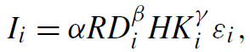
where I stands for the degree of innovative activity, RD represents R&D inputs, and HK represents human capital inputs.
Research pointed out the greatest source generating new economic knowledge is generally considered to be R&D. Other inputs in the knowledge production function include measures of human capital, skilled labor, and educational levels.
The logic of the production function held: innovative output was a function of innovative
inputs. Empirical evidence showed that the model was more robust at broader levels of aggregation, such as countries and industries: for both, higher levels of investment in R&D and economic knowledge implied greater innovation.
However, such robustness lacked at the microeconomic level of the firm, where there seemed to be no direct deterministic relationship between inputs and innovation. This suggested the existence of an externality, which researchers later identified in geography. As a result, the model was refocused and adapted with a spatial dimension to it.
In doing so, scholars faced 2 challenges:
- How could knowledge spill over and yet be spatially bounded within a geographic area?
- How can spillovers be measured and identified?
The second issue has no answer as measurements of knowledge are impossible as knowledge itself is invisible, and does not have any measurable aspect.
The first issue, however, has a more complicated answer. It is apparent that knowledge spills over: this is due to the fact that it is non-exclusive and non-rivalrous, which, in turn, represents the basis of knowledge externalities. The effect of such externalities is so important that there is no reason why knowledge should stop spilling over just because of borders or national boundaries. Therefore, theories explaining the spatial boundaries of spillovers were needed.
As we have previously seen (see Simona on tacit knowledge), tacit knowledge cannot be formalised and / or written down. Consequently, geographic proximity matters in transmitting it. This is where social interactions and the interactions in R&D and human capital formation assume greater importance. Feldman (1994a, 1994b) developed the theory that location mitigates the inherent uncertainty of innovative activity: proximity enhances the ability of firms to exchange ideas and be cognizant of important incipient knowledge.
Jaffe (1989) modified the original knowledge production function to account for space and product dimensions, resulting in the following:
where I is innovative output, IRD is private corporate expenditures on R&D, UR is the research expenditures undertaken at universities, and GC measures the geographic coincidence of university and corporate research.
This model proved to be robust at the geographic level of analysis with the output of innovation being the result of the innovative inputs in that location.

3 - DEFINITION OF INNOVATION CLUSTER
The above discussion, more specifically the spatial boundaries of knowledge spillovers, provides the basis for the definition of another important concept in this field, that of innovation clusters.
Porter (1990) defines clusters as a geographical concentration of interrelated companies, specialized suppliers, service providers, companies operating in related sectors and related institutions in specific fields, cooperating and competing with each other.
Particularly, competitive industries are not scattered throughout the economy but are usually linked together through vertical (buyer-seller) or horizontal (common customers, technology, channels) relationships.
Once a cluster forms, the whole group of industries becomes mutually supporting, benefiting each other. Aggressive rivalry in one industry spreads to others in the cluster, through spin-offs, through the exercise of bargaining power, and through diversification by established companies. Entry from other industries within the cluster spurs upgrading by stimulating diversity in R&D approaches and facilitating the introduction of new strategies and skills. Through the conduits of suppliers or customers who have contact with multiple competitors, information flows freely and innovations diffuse rapidly. Interconnections within the cluster, often unanticipated, lead to perceptions of new ways of competing and new opportunities. The cluster becomes a vehicle for maintaining diversity and overcoming the inward focus, inertia, inflexibility, and accommodation among rivals that slows or blocks competitive upgrading and new entry. As it is apparent, this is also where innovation clusters and knowledge spillovers link together.

A more recent definition is provided by Engel (2015), who states “clusters of Innovation (COI) are global economic “hot spots” where new technologies germinate at an astounding rate and where pools of capital, expertise, and talent foster the development of new industries and new ways of doing business. They are vibrant, effervescent ecosystems composed of startups, businesses that support the startup process, and mature enterprises (many of whom evolved rapidly from a startup history). In these ecosystems, resources of people, capital, and know-how are fluidly mobile and the pace of transactions is driven by a relentless pursuit of opportunity, staged financing, and short business model cycles.”
Engel identified the archetype of the clusters in the Silicon Valley and pointed out some key components defining such aggregations: entrepreneurs, venture capital investors, mature corporations and strategic investors, universities, government, R&D centers, and specialized service providers and management. He also distinguished key behaviors in these environments that favor the development of high-potential entrepreneurial ventures: a heightened mobility of resources (principally people, capital, and information — including intellectual property); an entrepreneurial process (the relentless pursuit of opportunity without regard for resource limitations); increased velocity of business development; a strategic global perspective; a culture of alignment of interests and transaction structures that reinforced that alignment; incentives and goals that lead to an affinity for collaboration; and development of global ties and bonds.
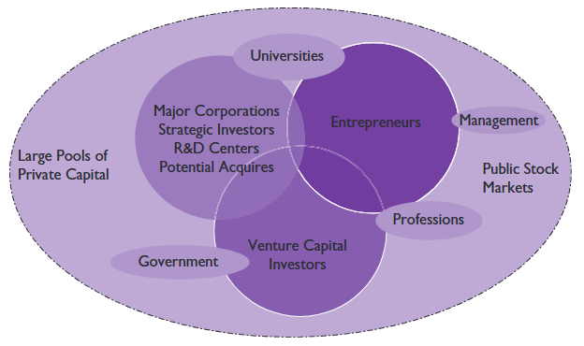
Figure 1 presents a graphic representation of how the key components function together in an innovation-centered business cluster.
Figure 1 The innovation engine of clusters of information

4 - MAP WITH MOST INNOVATIVE REGIONS AND TEASE ON WHY
The Global Innovation Index (GII) ranks the most innovative economies in the world in 2024 amongst 133 economies and unveils the world’s top S&T (Science & Technology) innovation clusters. It also reveals how to foster innovation via social entrepreneurship to make a societal impact that benefits everyone everywhere.
It is worth noticing how the most innovative regions are the ones where the majority of the clusters are located, namely Europe, North America and Southeast and East Asia.

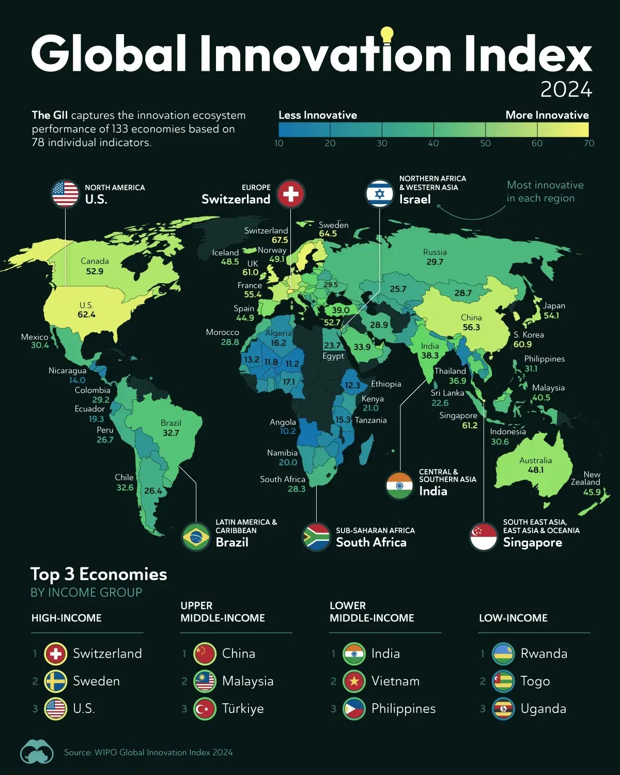
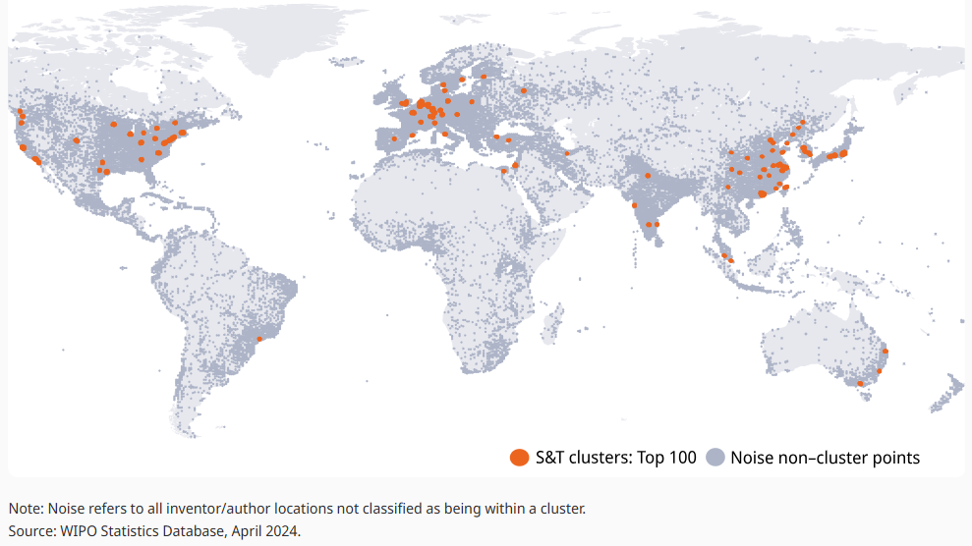
Top 100 clusters worldwide, 2024 (WIPO, 2024)

The key to why some regions are more innovative than others and why they tend to foster the formation of innovation clusters resides in the way knowledge spreads, which is the next point of the presentation.

REFERENCES
Thisse, J. F., & Henderson, V. (2004). Handbook of Regional and Urban Economics Volume 4. In Handbook of Regional and Urban Economics (Vol. 4). Elsevier Science & Technology.
De Bondt, R., Slaets, P., & Cassiman, B. (1992). The degree of spillovers and the number of rivals for maximum effective R &D. International Journal of Industrial Organization, 10(1), 35-54. https://doi.org/10.1016/0167-7187(92)90046-2
Poitiers, N., & Sekut, K. (2024). Knowledge spillovers and geopolitical challenges in global supply chains. (Working Paper 03/2024). Bruegel. https://www.bruegel.org/sites/default/files/private/2024-02/WP%2003_0.pdf
Chen, D.H.C., & Dahlman, C.J. (2006). The Knowledge Economy, The KAM Methodology And World Bank Operations. (35867). World Bank. http://documents.worldbank.org/curated/en/695211468153873436
Madanipour, A. (2011). Knowledge economy and the city: spaces of knowledge (1st ed.). Routledge. https://doi.org/10.4324/9780203816141
Jaffe, A. B. (1989). Real Effects of Academic Research. The American Economic Review, 79(5), 957–970. https://www.jstor.org/stable/1831431
Porter, M.E. (1990). The competitive advantage of nations. Harvard Business Review, 68(2), 73-93. https://hbr.org/1990/03/the-competitive-advantage-of-nations
WIPO. (2024). Global Innovation Index 2024. WIPO. https://www.wipo.int/web-publications/global-innovation-index-2024/en/cluster-ranking.html
Engel, J. S. (2015). Global Clusters of Innovation: Lessons from Silicon Valley. California Management Review, 57(2), 36–65. https://doi.org/10.1525/cmr.2015.57.2.36

pt 3 Enrico
We’ve seen that innovation tends to cluster in certain places, and that geography plays a key role. But what actually drives this clustering? The answer lies in how knowledge spreads, often unintentionally, from one actor to another.
This brings us to knowledge spillovers, and to the classical models that explain how they work in space.
Let’s start with the first major one: the Marshall–Arrow–Romer model. Sometimes called the specialization model, It’s based on the idea that when firms in the same industry are located close together, knowledge spreads more easily. Think of an industrial cluster where many companies work on similar problems, hire from the same labor pool, use the same suppliers, and attend the same industry events. Proximity reduces the cost of communicating complex, tacit knowledge, knowledge that can’t be easily codified or written down.
A great historical example of this is Detroit in the early to mid-20th century. The city became the global center for automobile manufacturing, not just because of Ford and GM, but because of the dense network of suppliers, workers, and know-how that was concentrated in one place. The Marshall–Arrow–Romer model predicts that this kind of local concentration enhances spillovers, accelerating innovation within that specialized industry.
But this model also reveals one of its own weaknesses: what happens when the cluster becomes too specialized? In Detroit’s case, when the global auto industry shifted toward different technologies and production strategies, the city struggled to adapt. Knowledge spillovers can be powerful, but only if the environment remains dynamic and resilient.
That leads us to an alternative model proposed by Jane Jacobs, often referred to as the Jacobs externalities or the diversity model. Jacobs argued that innovation isn’t just a product of specialization, it’s more likely to emerge when different kinds of knowledge collide. Her insight was that cities promote innovation not just by concentrating similar firms, but by mixing different industries in the same place.
In a diverse urban environment, ideas from unrelated sectors can combine in novel ways. For example, in a city like New York, financial firms might interact with tech startups, media companies, and even the art world. This cross-pollination can lead to new hybrid industries such as fintech, that wouldn’t emerge in more specialized environments.
Empirical studies support this. Audretsch and Feldman (1996), for example, found that industries relying more heavily on new economic knowledge tend to exhibit greater geographic concentration of innovative activity, even after controlling for where production happens. And diversity, especially when it brings together complementary skills and overlapping scientific bases, often leads to greater innovation intensity.
So we have two models: specialization, which promotes deep knowledge sharing within industries; and diversity, which fosters creativity across sectors. In reality, both forces often operate in parallel. Some places benefit from one more than the other, depending on their industrial base and history.
But beyond these models, there are concrete mechanisms, real-world channels, through which knowledge spillovers happen.
One major mechanism is labor mobility. When skilled workers move between firms, they carry with them not just their training, but also the informal, tacit knowledge they’ve acquired on the job. Think about a software engineer leaving Google to start their own company. They bring more than just coding skills — they carry a mindset, a culture, a toolkit of best practices that can seed innovation elsewhere. This is a major reason why regions with high job mobility — like Silicon Valley — are such powerful innovation hubs.
Another key channel is the role of universities and public research institutions. Universities don’t just educate students: they create knowledge, publish research, generate patents, and often collaborate with industry. In the literature, this is one of the clearest cases of intentional and beneficial knowledge spillovers. Audretsch and Feldman (1996) found that university research activity significantly boosts innovation in nearby firms, especially small ones, which typically conduct less in-house R&D.
This spillover isn’t just theoretical. Institutions like MIT, Stanford, or ETH Zurich are surrounded by dense ecosystems of startups and high-tech firms. These firms benefit from access to research, but also from informal links: talent pipelines, networking events, and shared norms that support experimentation and learning.
A third mechanism is entrepreneurship itself. As Audretsch (1995) pointed out, the movement of knowledge often doesn’t happen through big, existing firms, but through new ventures created by individuals who leave universities or corporations. Entrepreneurship acts as a conduit for turning tacit knowledge into economic output. This is especially visible in science-based sectors like biotech, where researchers commercialize their discoveries through startups.
Finally, there’s a growing recognition that institutions and policies shape whether spillovers happen at all. Laws, norms, and government support all influence the channels of knowledge transmission. For example, if immigration policies are restrictive, it becomes harder to attract or retain the kind of talent that fuels spillovers. If IP protection is too strict, it can stifle the diffusion of ideas. These are questions we’ll explore more in the next section.
In sum, knowledge spillovers are not just theoretical constructs. They’re embedded in the geography of industries, the mobility of people, the openness of institutions, and the vibrancy of cities. Whether through the tight networks of a specialized cluster or the eclectic mix of an urban environment, the way ideas move, as well as who has access to them, can shape entire economies.
And so, as we move on to the next part of the lecture, Sofia will take us deeper into the role of institutions and public authorities in making sure these spillovers don’t just happen by accident but become part of a strategy for innovation and growth.

pt 5 Teo
In this section of the presentation, I’ll give some insights on what could limit knowledge spillovers.
Let’s refresh the meaning of knowledge spillovers first: this happens when knowledge created by one person, company, or organization benefits others—without those others having to pay for it. It's like a positive side effect of innovation, learning, or research.
For knowledge spillovers to happen there needs to be a recognition of the opportunity, and no external barriers, collaborative research environment
What hinders knowledge spillovers? First thing to say, is that by logic, it is limited by a lack of those elements that facilitate it, which we have seen before. *summary* *insert*
But then there are in particular two barriers I want to focus on:
- Geopolitics
- Limited absorptive capacity

GEOPOLITICS
https://www.bruegel.org/sites/default/files/private/2024-02/WP%2003_0.pdf
So, what has geopolitics to do with knowledge spillovers?
One of the most powerful vehicles for knowledge flows has been global supply chains. They allow firms to tap into international expertise, share innovations, and benefit from being part of a broader ecosystem of technological progress.
But today, those flows are facing serious roadblocks.
Across the globe, we’re seeing more and more policies aimed at limiting knowledge transfer and collaboration—often in the name of national security, economic independence, or strategic competition. These policies include things like restricting exports of high-tech goods, blocking acquisitions of advanced firms, or putting up barriers to research collaborations between countries.

1. Rise of industrial policy and tech sovereignty
One of those policies, are industrial policies.
Many countries are turning inward with them designed to reduce dependency on others under many aspects.
“Industrial Policy is defined as the strategic effort by the state to encourage economic transformation, i.e. the shift from lower to higher productivity activities, between or within sectors. Specifically, industrial policy refers to “any type of selective government intervention or policy that attempts to alter the structure of production in favour of sectors [or activities] that are expected to offer better prospects for economic growth in a way that would not occur in the absence of such intervention in the market equilibrium” (Pack and Saggi, 2006)
Typical types of interventions include subsidies, taxes and trade tariffs. They are moved by motives such as protectionism, environmental protection, and geopolitics.
They affect knowledge flows, because by altering the market structure they:
- reduce competition, because now firms are shielded by the government and hence they become more complacent, less risk taking, and with less need to improve their operations.
- In a sense they have a weakened incentive to innovate. Example of electric vehicles
- Also industrial policies may cut off channels of knowledge flows, especially when they are of a protectionist nature, as it limits innovation spillovers from foreigners
- Lastly certain industrial policies limit foreign direct investments.
This is not just about money. Indeed when international companies invest in a country, they bring in innovation, and knowledge often spills over to local firms. But protectionist policies—especially those that block more advanced foreign companies from entering local markets—can disrupt these benefits.
An example of what an industrial policy could look like, is the U.S., the Inflation Reduction Act:
USA gov gives subsidies to a firm—but only if key components aren't made in China.
Another one is from Europe. When the Chinese company Midea acquired German robotics firm KUKA in 2017, EU got worried of losing its technology to a chinese rival. Since then EU created stricter rules of fdi
2. Export controls and Tech restrictions
Often linked with geopolitical reasons, are export controls and tech restrictions.
“Export Control Laws are a set of regulations and laws that restrict the transfer or disclosure of goods, technology, software, services, and information to foreign nationals in the reference country and abroad.”
Violating them may cause civil and criminal penalties.
In many countries they exist for:
- dual-use technologies
- military technologies

ex: US restricted exports of chip-making equipment and advanced semiconductors to China
They limit knowledge spillovers, because they
- reduce collaborative research, because researchers are likely to avoid partnerships with entities in restricted countries, to sidestep complex licensing requirements and legal implications
- are a barrier to international talent, as firms are discouraged from hiring foreigners
So for both of these points, the result is less diversity of knowledge.
- It then causes innovation offshoring, which means that firms relocate R&D to countries with fewer restrictions and more favourable innovation ecosystems, damaging the nation imposing them.

3. Sanctions
Maybe the most salient geopolitical block to knowledge flows, are sanctions.
“Sanctions are economic and political measures that aim to influence the behaviour of a state, a group or individuals. They are usually made by many nations simultaneously through an international agreement.”

Typical motivations for raising them include: forcing cooperation with international law, containing a threat to peace and condemning an act.
Typical typologies of sanctions are economic sanctions, such as imposing financial and trade restrictions.
And diplomatic sanctions, which are political measures to isolate or influence a state.
ex: Russia after Crimea 2014 and Ukraine 2022 big wave of sanctions. Since the invasion of Ukraine as result of the heavy sanctions, over 1000 companies have withdrawn operations from Russia, either partially or completely.
includes both suspending exports or imports, but also cutting off joint-ventures and collaborations. Reminder: exports and imports are a source of knowledge acquisition, and partnerships are a source of knowledge flow.
EX of big names: apple, sony, adidas, ferrari, disney and many more interrupted sales or partnerships

- Once again one research and innovation is limited. Indeed Sanctions require governmental approval for all interactions regarding the sanctioned topic (ex: oil extraction technologies) (regardless of whether money is exchanged or not) with people subject to targeted sanctions or located in a comprehensively sanctioned destination. This limits research and innovation.
Sanctions require governmental approval for all interactions regarding the sanctioned topic (ex: oil extraction technologies) with people subject to targeted sanctions.
EX: a study showed a significant decline of EU-Russia scientific co-publications after Crimea even of 2014, which ranged between 15% and 70% depending on the research topic
- They also affect research quality, because they isolate researchers from the global scientific community. This reduces opportunities for peer review and feedback and sharing ideas.
- Another way in which it affects knowledge flows, is when there are financial sanctions. They can block access to international funding sources and essential research materials, which forces researchers to rely on limited domestic resources, potentially slowing the pace of scientific advancement.
- Lastly they affect firm behaviour, which reduce corporate investment and research and development expenditures
4. Deglobalisation
All these trends are part of a bigger picture: deglobalisation. Since World War II, global trade as a share of GDP kept growing. But recently this slowed down.
When trade slows and supply chains shrink, opportunities for sharing knowledge across borders shrink with them—especially for developing countries trying to integrate into the global economy.
To sum up: knowledge spillovers are essential for innovation, but they’re increasingly caught in the crossfire of geopolitics. Governments are understandably trying to protect their interests—whether it’s by securing supply chains, reshoring industries, or limiting the flow of strategic technologies. But in doing so, they risk slowing down the global exchange of knowledge that has powered so much progress in recent decades.
The challenge going forward is finding a balance—between protecting national security and ensuring that innovation continues to thrive, not just within countries, but across them.

ABSORPTIVE CAPACITY
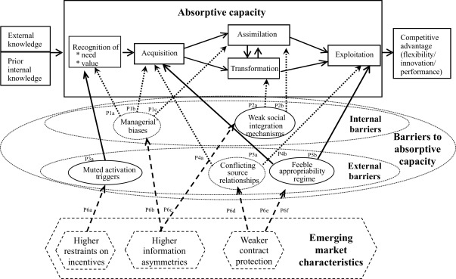
https://en.wikipedia.org/wiki/Absorptive_capacity
https://www.sciencedirect.com/science/article/pii/S1090951617304893
Moving to the next barrier to knowledge spillover, is absorptive capacity.
First thing first, what is absorptive capacity?
It is a concept in management and organizational theory that refers to an organization's dynamic ability to:
- recognize the value of new information
- assimilate it
- apply it for commercial purposes, particularly in terms of innovation and technology adoption
The concept is strongly linked to knowledge spillovers between firms and innovation. A firm can exploit knowledge to create economic value, only if it recognises the value of the knowledge it’s exposed to, and is able to incorporate it to create innovation.
A concept related to it, is the “desorptive capacity”, defined as "as an organization's ability to identify technology transfer opportunities based on a firm's outward technology transfer strategy and to facilitate the technology's application at the recipient".^{[32]}
Thus, it influences the volume of knowledge transfer and comprises two process steps - identification and transfer.
The core models that have been developed around this concept are those of Cohen and Levinthal and Zahra and George’s. Put together they give a great understanding on what elements facilitate or hinder the absorptive capacity of a firm.

COHEN AND LEVINTHAL MODEL:
First of all they say that absorptive capacity is cumulative, which means that constant effort to increase absorptive capacity is better compared to a single investment to try and catch up.
What facilitates absorptive capacity is:
- prior related knowledge
- diversity of background
- diversity of team members

ZAHRA AND GEORGE’S MODEL:
They divide absorptive capacity into 2 types::
- POTENTIAL ABSORPTIVE CAPACITY:
Refers to the ability of a firm to identify, acquire, understand and interpret external knowledge relevant to its operations
- REALIZED ABSORPTIVE CAPACITY:
Refers to the ability of a firms to combine existing knowledge and newly acquired knowledge, to apply it to a product or service that generates financial returns

There are different elements that create absorptive capacity, and the level of development of each of them of a firm can be observed by specific indicators.
- Knowledge acquisition capability
(the number of years of experience of the R&D department, the amount of R&D investment)
- Assimilation capability
(the number of cross-firm patent citations, the number of citations made in a firm's publications to research developed in other firms)
- Transformation capability
(the number of new product ideas, the number of new research projects initiated)
- Exploitation capability
(the number of patent, the number of new product announcements, the length of product development cycle)
All those capabilities, are facilitated by social integration, knowledge infrastructure, management support and relational capability, innovation routines.
Now that we have a better understanding of what absorptive capacity is, what facilitates it, and why it’s important for knowledge spillovers, we’ll see what are barriers to it.

Barriers can be grouped as follows:
- INTERNAL: managerial biases, weak social integration mechanisms
- EXTERNAL: muted activation triggers,conflicting source relationships, and feeble appropriability regime
Let’s take a look at what they mean:
INTERNAL
- MANAGERIAL BIASES
are prejudices that managers have for or against sources of knowledge, which result in not perceiving the value of and need for external knowledge.
ex is that of the chinese automobile corporation NAC (Nanjing Automobile Corporation, chinese), where workers showed cultural and psychological resistance to using foreign technology from Japanese company Isuzu (e.g., calling Japanese-imported molds “scrap metal”), even when managers had arranged technology transfers.
- WEAK SOCIAL INTEGRATION MECHANISMS
Social integration mechanisms are processes within the firm that enable the coordination of actions and activities among employees. Ex: incentives, favourable organizational infrastructure
If they are absent or weak, agency problems arise, which limit the assimilation and transformation on external knowledge.
EX:
NAC had many subsidiaries and international joint ventures, but did not learn from them because it had no systematic coordination systems and mutual supportive culture that would have facilitated learning.

EXTERNAL
- MUTED ACTIVATION TRIGGERS
When they are present, managers have limited recognition of the need and value of external knowledge
EXAMPLE: For example, before the beginning of China’s transition toward capitalism in 1978, NAC’s managers were not compelled to upgrade and incorporate foreign technology, even if they recognized the value of foreign technology as being superior and useful for upgrading capabilities. With no competitive pressures from foreign firms and a limited number of domestic competitors, the firm was able to sell without much effort, reducing the incentive of managers to seek and incorporate the external technology. Once the economy opened, however, the activation triggers were no longer muted, but rather strong.

- FEEBLE APPROPRIABILITY REGIME
It refers to a regime where intellectual property rights and contract enforcement are weak. This situation discourages external knowledge sources from sharing valuable knowledge, even in a setting of collaboration, because there is concern about imitation and lack of protection.
NAC had a 10-year long collaboration with Iveco with technology transfer. But NAC was not able to fully understand the design maps because the Italian side did not explain the key technology to their technicians and engineers although the license transfer agreement stated that the Italians should do.

The study concludes by highlighting that in emerging barriers are reinforced, because of the strong government intervention, weak regulatory enforcement and contract protection, which reduce firms' incentives to pursue external knowledge for competitiveness

